5.1-

Task-2

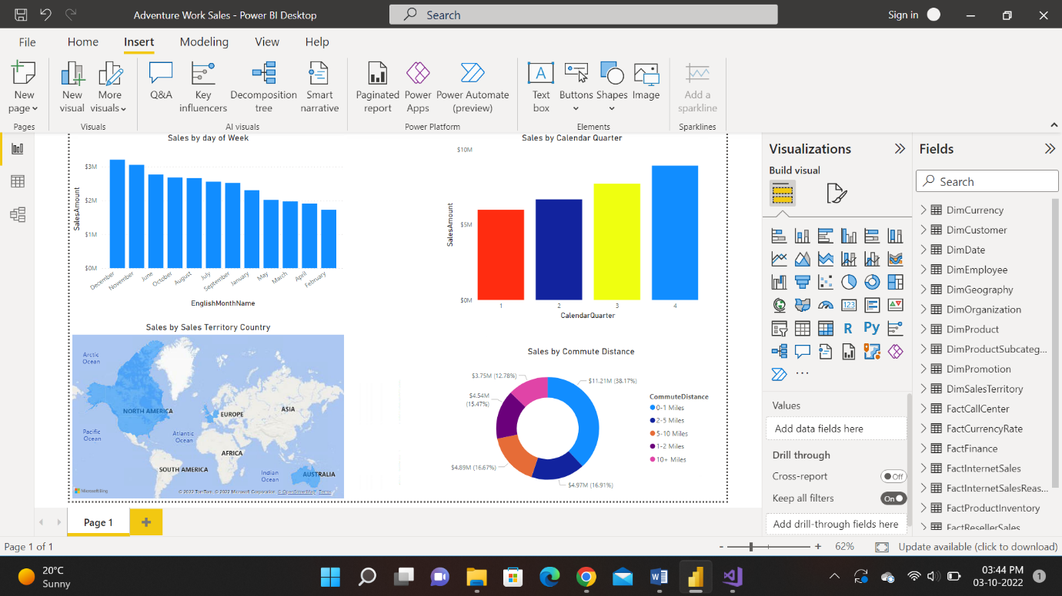

Task-3

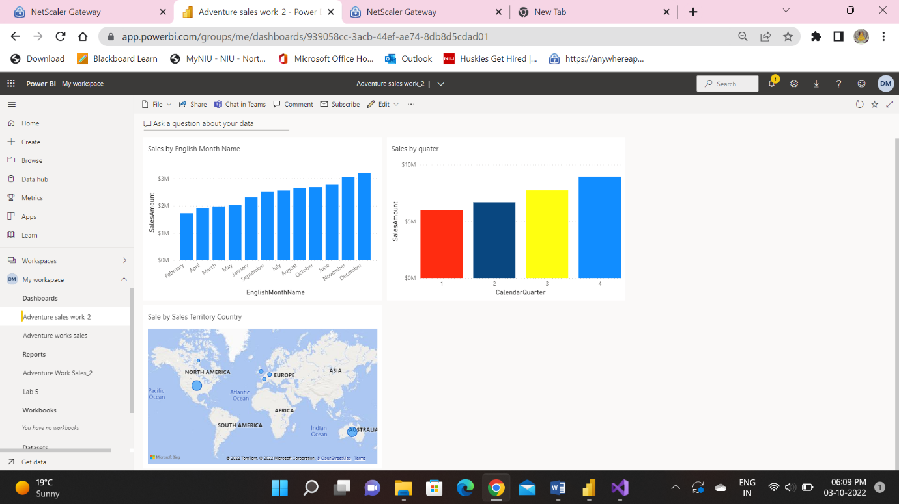

Task-4

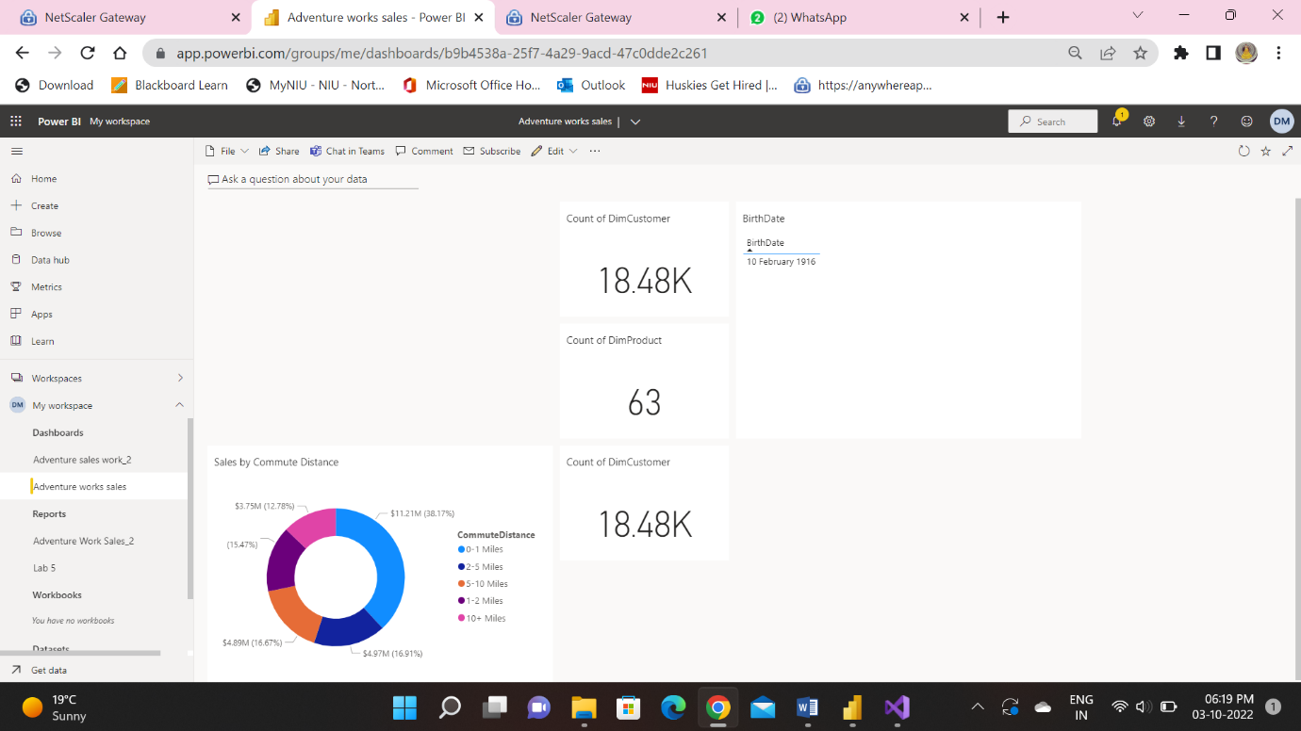

5.2-

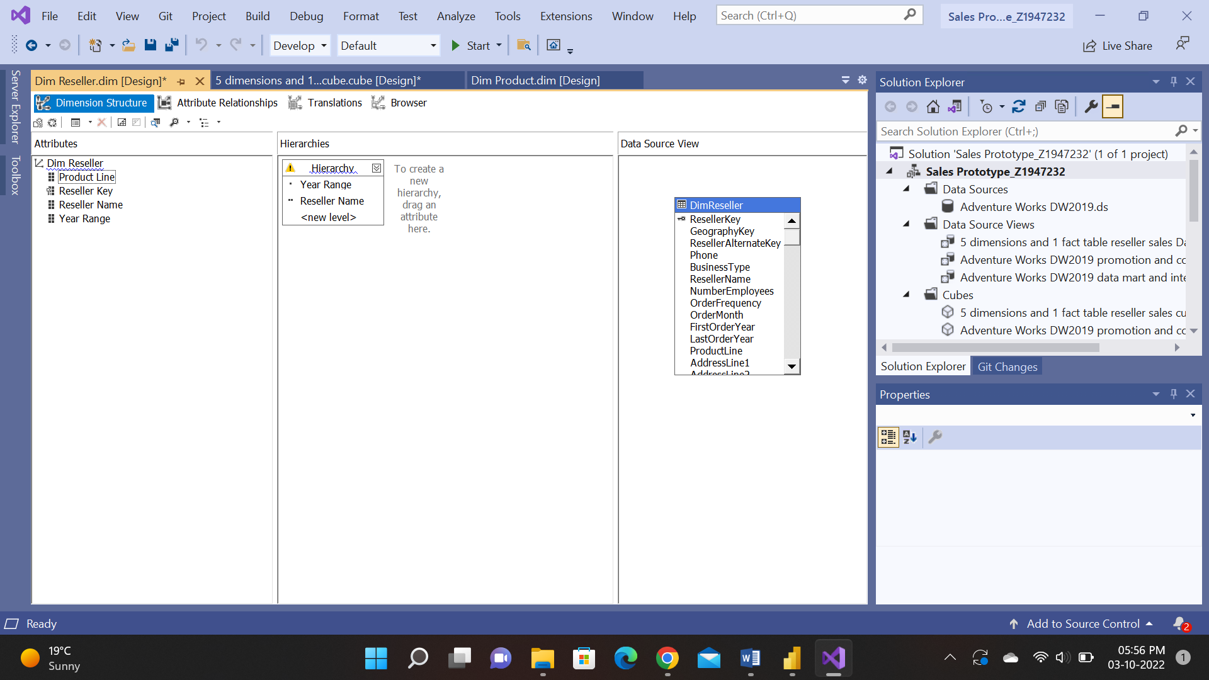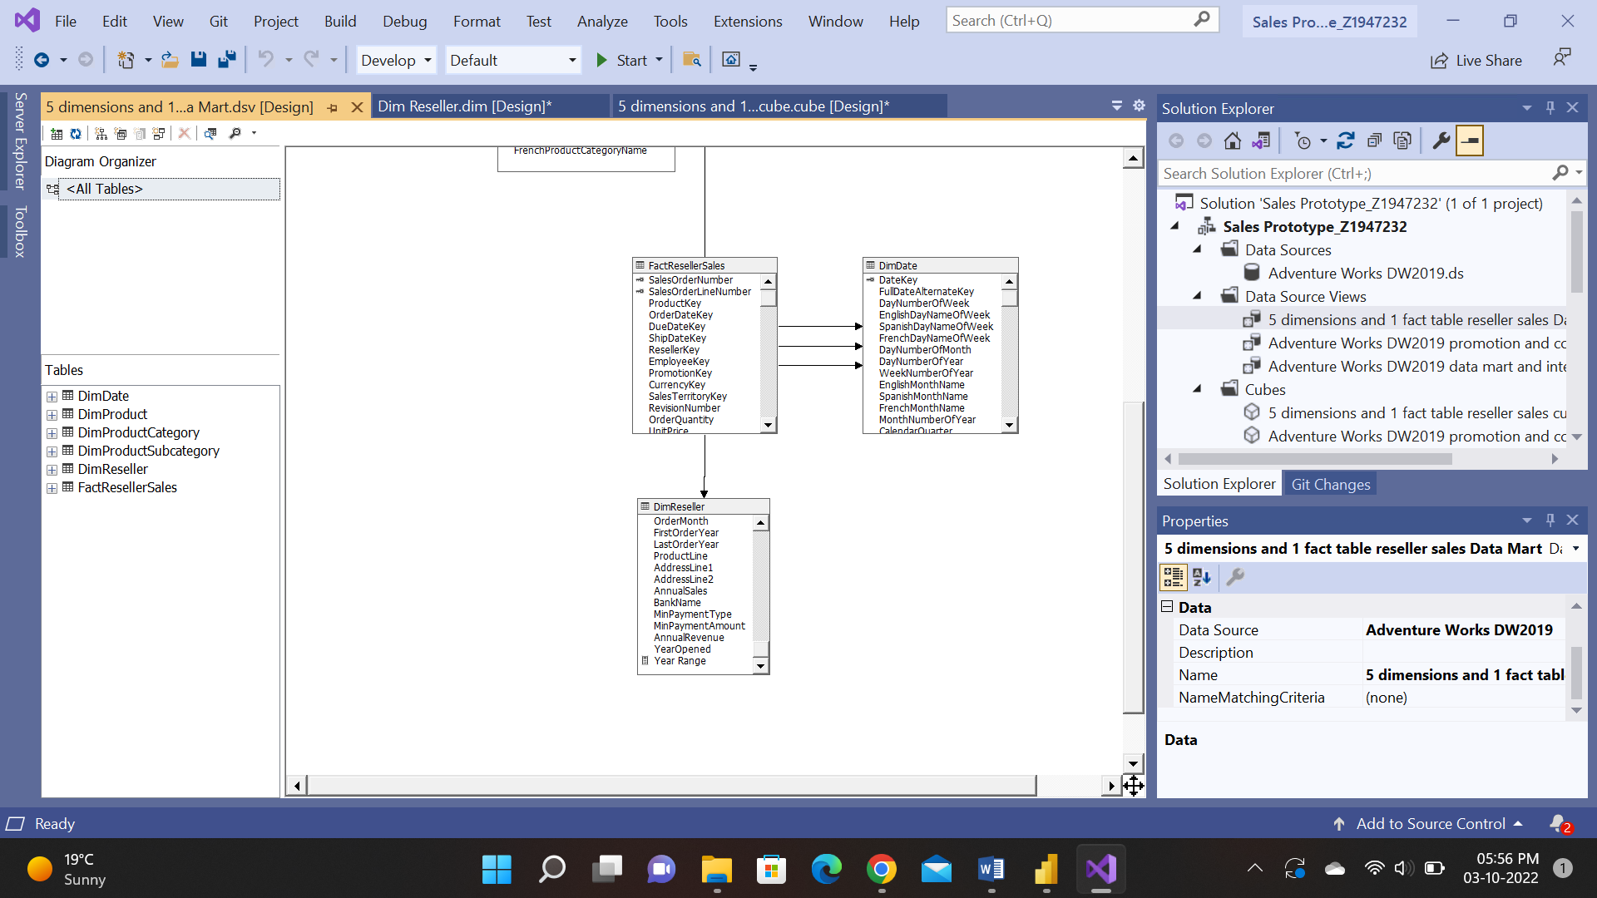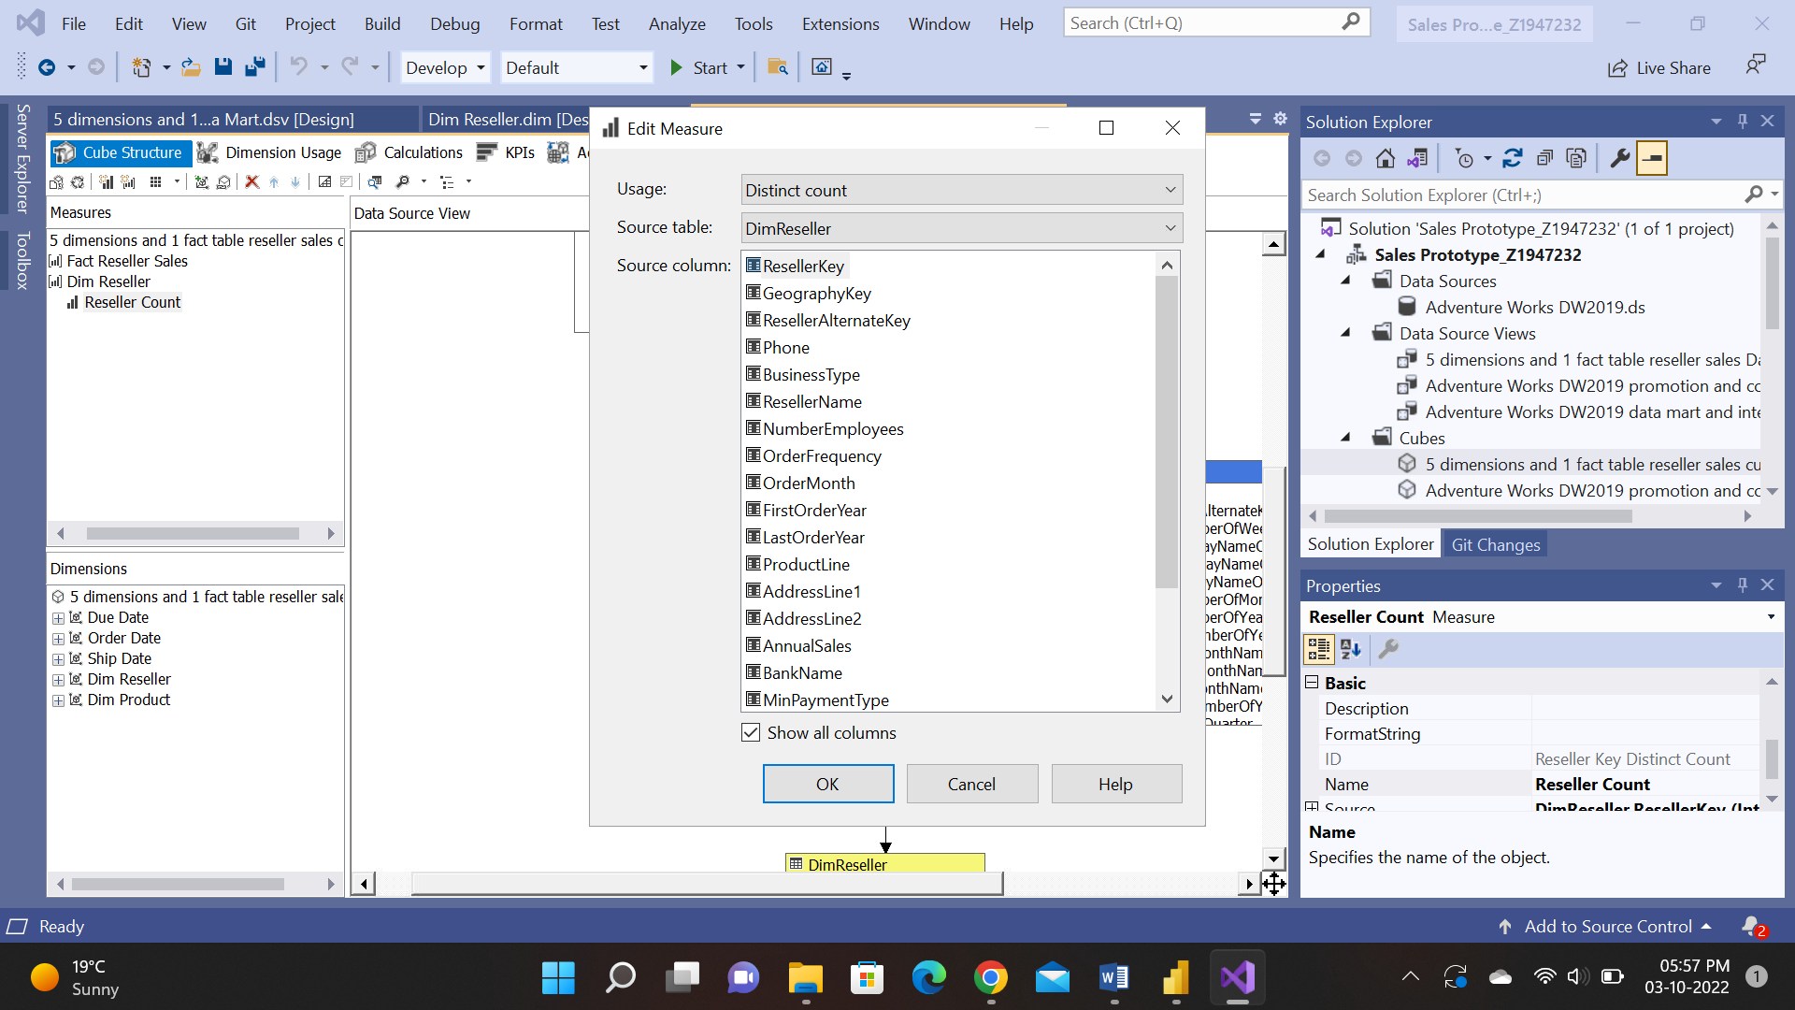

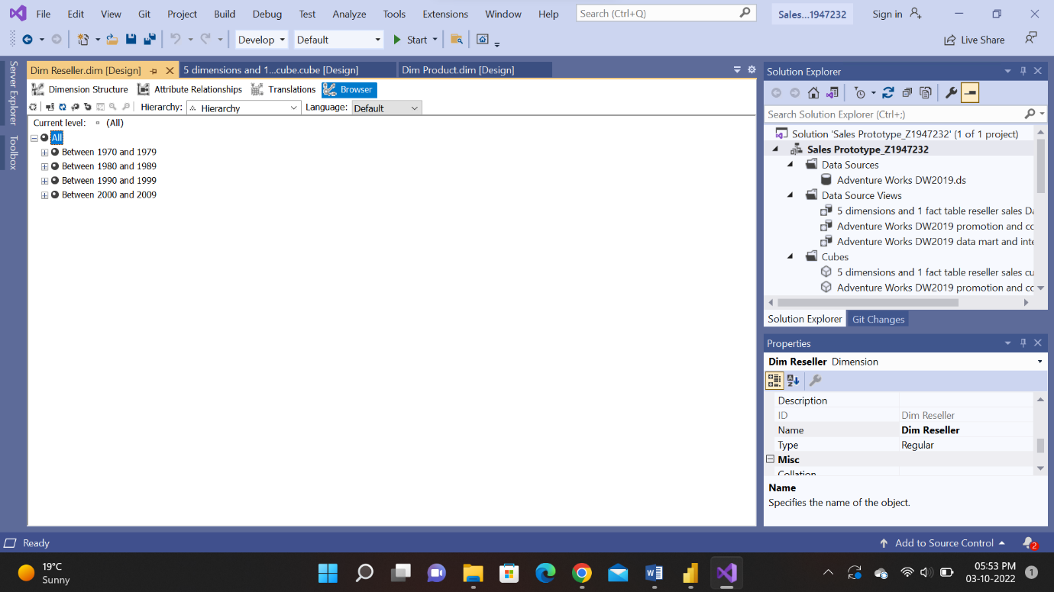

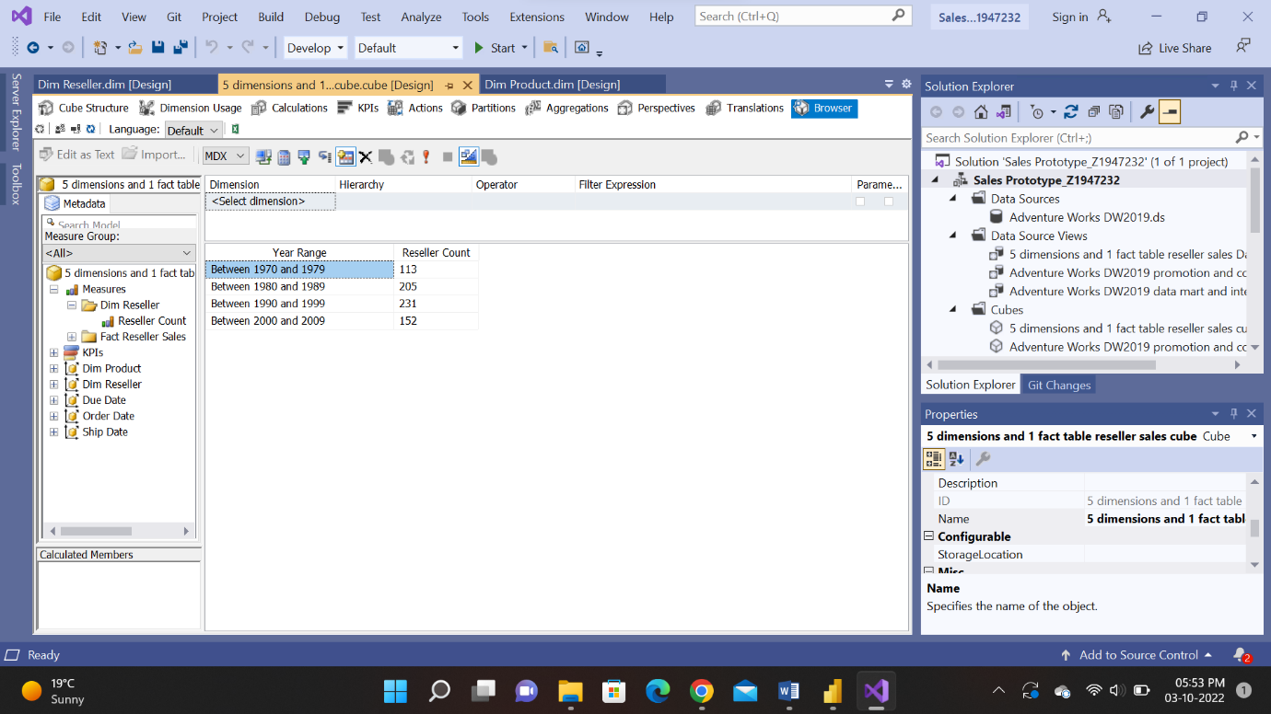

Steps :

1. Open the data source view and on the dim reseller create named calculations
2. After deploying go to create an hierarchy in the dim reseller dimension tab and check after processing if its in the proper structure
3. Then go to the cube and then create a new measure to create the number of resellers. Now select distinct count and reseller name and then process.
4. After this step open the cube again and drag the year range and distinct reseller to the space. Then we will get the output.